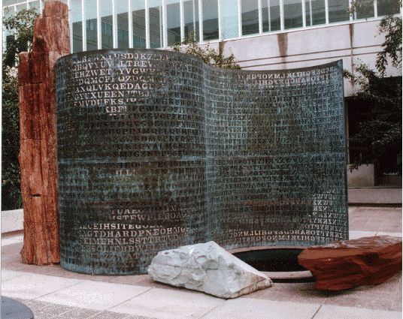
Remember a few years ago or longer that the group thought the white rock had something carved on it? It looks like 35 or it looks like 3S or it may be JS (Sanborn’s initials). Above pic is from Elonka’s visit to Kryptos.
Now look at the 2nd picture below from a different angle (picture 2 is by Jim Gillogly). Notice the way the side of this rock is flat and slopes down.
Now look at the 3rd picture with the horizontal lines (also from Jim Gillogly). Does this look like the same shape as in picture 2? I’m not very good at manipulating photos and overlaying them on top of each other. In my eyes, they are very similar in shape. If you put them together (pic 3 may need to be rotated or flipped?), do the horizontal lines lead to something?
I haven’t ever seen any discussion about these two objects.
